**INTERNSHIP TASK**

Dear All,

You are kindly requested to write a function in Python to scrape tabular information from the Agmarket website and submit it on Monday (6th March 2023) before 3 pm.

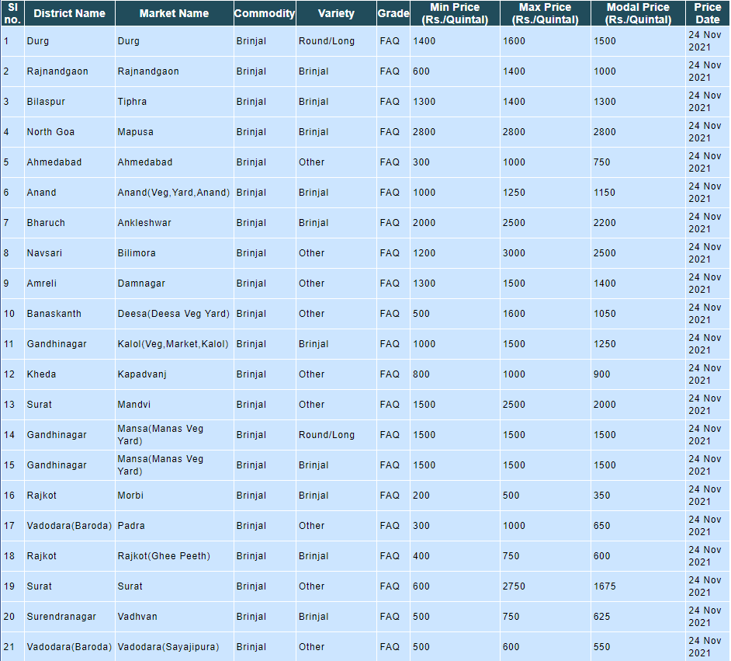

* Only information from the first page needs to be scrapped.
* The code written to scrape data must also be able to save the data in csv format.
* The code must be written with brief explanation.
* The Code along with the csv file should be emailed to [fathima.a@sjri.res.in](mailto:fathima.a@sjri.res.in)
* Each student has been provided with a link from which the data needs to be scrapped.
* For any queries contact [fathima.a@sjri.res.in](mailto:fathima.a@sjri.res.in) or [ashikh.a@sjri.res.in](mailto:ashikh.a@sjri.res.in)

Regards,

Fathima Ayoob

**Links**:

|  |  |
| --- | --- |
| ***Name*** | ***Links*** |
| Agnib Pathak | https://agmarknet.gov.in/SearchCmmMkt.aspx?Tx_Commodity=153&Tx_State=0&Tx_District=0&Tx_Market=0&DateFrom=24-Nov-2021&DateTo=24-Nov-2021&Fr_Date=24-Nov-2021&To_Date=24-Nov-2021&Tx_Trend=0&Tx_CommodityHead=Carrot&Tx_StateHead=--Select--&Tx_DistrictHead=--Select--&Tx_MarketHead=--Select- |
| Amrithavarshini V | https://agmarknet.gov.in/SearchCmmMkt.aspx?Tx_Commodity=17&Tx_State=0&Tx_District=0&Tx_Market=0&DateFrom=24-Nov-2021&DateTo=24-Nov-2021&Fr_Date=24-Nov-2021&To_Date=24-Nov-2021&Tx_Trend=0&Tx_CommodityHead=Apple&Tx_StateHead=--Select--&Tx_DistrictHead=--Select--&Tx_MarketHead=--Select-- |
| Arkaprabha Poddar | https://agmarknet.gov.in/SearchCmmMkt.aspx?Tx_Commodity=49&Tx_State=0&Tx_District=0&Tx_Market=0&DateFrom=24-Nov-2021&DateTo=24-Nov-2021&Fr_Date=24-Nov-2021&To_Date=24-Nov-2021&Tx_Trend=0&Tx_CommodityHead=Arhar+(Tur%2fRed+Gram)(Whole)&Tx_StateHead=--Select--&Tx_DistrictHead=--Select--&Tx_MarketHead=--Select-- |
| Ashika James | https://agmarknet.gov.in/SearchCmmMkt.aspx?Tx_Commodity=260&Tx_State=0&Tx_District=0&Tx_Market=0&DateFrom=24-Nov-2021&DateTo=24-Nov-2021&Fr_Date=24-Nov-2021&To_Date=24-Nov-2021&Tx_Trend=0&Tx_CommodityHead=Arhar+Dal(Tur+Dal)&Tx_StateHead=--Select--&Tx_DistrictHead=--Select--&Tx_MarketHead=--Select-- |
| Harsha K G | https://agmarknet.gov.in/SearchCmmMkt.aspx?Tx_Commodity=83&Tx_State=0&Tx_District=0&Tx_Market=0&DateFrom=24-Nov-2021&DateTo=24-Nov-2021&Fr_Date=24-Nov-2021&To_Date=24-Nov-2021&Tx_Trend=0&Tx_CommodityHead=Ashgourd&Tx_StateHead=--Select--&Tx_DistrictHead=--Select--&Tx_MarketHead=--Select-- |
| Joan Jose M | https://agmarknet.gov.in/SearchCmmMkt.aspx?Tx_Commodity=28&Tx_State=0&Tx_District=0&Tx_Market=0&DateFrom=24-Nov-2021&DateTo=24-Nov-2021&Fr_Date=24-Nov-2021&To_Date=24-Nov-2021&Tx_Trend=0&Tx_CommodityHead=Bajra(Pearl+Millet%2fCumbu)&Tx_StateHead=--Select--&Tx_DistrictHead=--Select--&Tx_MarketHead=--Select-- |
| Jones M | https://agmarknet.gov.in/SearchCmmMkt.aspx?Tx_Commodity=19&Tx_State=0&Tx_District=0&Tx_Market=0&DateFrom=24-Nov-2021&DateTo=24-Nov-2021&Fr_Date=24-Nov-2021&To_Date=24-Nov-2021&Tx_Trend=0&Tx_CommodityHead=Banana&Tx_StateHead=--Select--&Tx_DistrictHead=--Select--&Tx_MarketHead=--Select-- |
| Priyanka Dey | https://agmarknet.gov.in/SearchCmmMkt.aspx?Tx_Commodity=29&Tx_State=0&Tx_District=0&Tx_Market=0&DateFrom=24-Nov-2021&DateTo=24-Nov-2021&Fr_Date=24-Nov-2021&To_Date=24-Nov-2021&Tx_Trend=0&Tx_CommodityHead=Barley+(Jau)&Tx_StateHead=--Select--&Tx_DistrictHead=--Select--&Tx_MarketHead=--Select-- |
| Namrata Singh | https://agmarknet.gov.in/SearchCmmMkt.aspx?Tx_Commodity=94&Tx_State=0&Tx_District=0&Tx_Market=0&DateFrom=24-Nov-2021&DateTo=24-Nov-2021&Fr_Date=24-Nov-2021&To_Date=24-Nov-2021&Tx_Trend=0&Tx_CommodityHead=Beans&Tx_StateHead=--Select--&Tx_DistrictHead=--Select--&Tx_MarketHead=--Select-- |
| Nivedya R T | https://agmarknet.gov.in/SearchCmmMkt.aspx?Tx_Commodity=157&Tx_State=0&Tx_District=0&Tx_Market=0&DateFrom=24-Nov-2021&DateTo=24-Nov-2021&Fr_Date=24-Nov-2021&To_Date=24-Nov-2021&Tx_Trend=0&Tx_CommodityHead=Beetroot&Tx_StateHead=--Select--&Tx_DistrictHead=--Select--&Tx_MarketHead=--Select-- |
| Prateek Kumar | https://agmarknet.gov.in/SearchCmmMkt.aspx?Tx_Commodity=263&Tx_State=0&Tx_District=0&Tx_Market=0&DateFrom=24-Nov-2021&DateTo=24-Nov-2021&Fr_Date=24-Nov-2021&To_Date=24-Nov-2021&Tx_Trend=0&Tx_CommodityHead=Bengal+Gram+Dal+(Chana+Dal)&Tx_StateHead=--Select--&Tx_DistrictHead=--Select--&Tx_MarketHead=--Select-- |
| Staina Joseph | https://agmarknet.gov.in/SearchCmmMkt.aspx?Tx_Commodity=6&Tx_State=0&Tx_District=0&Tx_Market=0&DateFrom=24-Nov-2021&DateTo=24-Nov-2021&Fr_Date=24-Nov-2021&To_Date=24-Nov-2021&Tx_Trend=0&Tx_CommodityHead=Bengal+Gram(Gram)(Whole)&Tx_StateHead=--Select--&Tx_DistrictHead=--Select--&Tx_MarketHead=--Select-- |
| Vinay Rawat | https://agmarknet.gov.in/SearchCmmMkt.aspx?Tx_Commodity=85&Tx_State=0&Tx_District=0&Tx_Market=0&DateFrom=24-Nov-2021&DateTo=24-Nov-2021&Fr_Date=24-Nov-2021&To_Date=24-Nov-2021&Tx_Trend=0&Tx_CommodityHead=Bhindi(Ladies+Finger)&Tx_StateHead=--Select--&Tx_DistrictHead=--Select--&Tx_MarketHead=--Select-- |
| Maria Elisha Monteiro | https://agmarknet.gov.in/SearchCmmMkt.aspx?Tx_Commodity=81&Tx_State=0&Tx_District=0&Tx_Market=0&DateFrom=24-Nov-2021&DateTo=24-Nov-2021&Fr_Date=24-Nov-2021&To_Date=24-Nov-2021&Tx_Trend=0&Tx_CommodityHead=Bitter+gourd&Tx_StateHead=--Select--&Tx_DistrictHead=--Select--&Tx_MarketHead=--Select-- |
| Neelabha Banerjee | https://agmarknet.gov.in/SearchCmmMkt.aspx?Tx_Commodity=8&Tx_State=0&Tx_District=0&Tx_Market=0&DateFrom=24-Nov-2021&DateTo=24-Nov-2021&Fr_Date=24-Nov-2021&To_Date=24-Nov-2021&Tx_Trend=0&Tx_CommodityHead=Black+Gram+(Urd+Beans)(Whole)&Tx_StateHead=--Select--&Tx_DistrictHead=--Select--&Tx_MarketHead=--Select-- |
| Priyanka R | https://agmarknet.gov.in/SearchCmmMkt.aspx?Tx_Commodity=264&Tx_State=0&Tx_District=0&Tx_Market=0&DateFrom=24-Nov-2021&DateTo=24-Nov-2021&Fr_Date=24-Nov-2021&To_Date=24-Nov-2021&Tx_Trend=0&Tx_CommodityHead=Black+Gram+Dal+(Urd+Dal)&Tx_StateHead=--Select--&Tx_DistrictHead=--Select--&Tx_MarketHead=--Select-- |
| Ria Liz Luke | https://agmarknet.gov.in/SearchCmmMkt.aspx?Tx_Commodity=38&Tx_State=0&Tx_District=0&Tx_Market=0&DateFrom=24-Nov-2021&DateTo=24-Nov-2021&Fr_Date=24-Nov-2021&To_Date=24-Nov-2021&Tx_Trend=0&Tx_CommodityHead=Black+pepper&Tx_StateHead=--Select--&Tx_DistrictHead=--Select--&Tx_MarketHead=--Select-- |
| Soham Bhattacharjee | https://agmarknet.gov.in/SearchCmmMkt.aspx?Tx_Commodity=82&Tx_State=0&Tx_District=0&Tx_Market=0&DateFrom=24-Nov-2021&DateTo=24-Nov-2021&Fr_Date=24-Nov-2021&To_Date=24-Nov-2021&Tx_Trend=0&Tx_CommodityHead=Bottle+gourd&Tx_StateHead=--Select--&Tx_DistrictHead=--Select--&Tx_MarketHead=--Select-- |
| Sundaraavadhani A S | https://agmarknet.gov.in/SearchCmmMkt.aspx?Tx_Commodity=35&Tx_State=0&Tx_District=0&Tx_Market=0&DateFrom=24-Nov-2021&DateTo=24-Nov-2021&Fr_Date=24-Nov-2021&To_Date=24-Nov-2021&Tx_Trend=0&Tx_CommodityHead=Brinjal&Tx_StateHead=--Select--&Tx_DistrictHead=--Select--&Tx_MarketHead=--Select-- |
| Neha Mathew | https://agmarknet.gov.in/SearchCmmMkt.aspx?Tx_Commodity=164&Tx_State=0&Tx_District=0&Tx_Market=0&DateFrom=24-Nov-2021&DateTo=24-Nov-2021&Fr_Date=24-Nov-2021&To_Date=24-Nov-2021&Tx_Trend=0&Tx_CommodityHead=Capsicum&Tx_StateHead=--Select--&Tx_DistrictHead=--Select--&Tx_MarketHead=--Select-- |